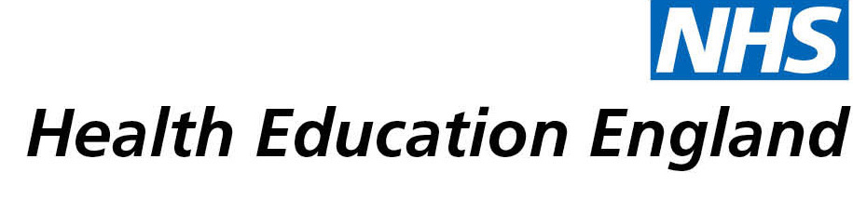

# Library and Knowledge Services case study

# *Moorfields Eye Hospital NHS Foundation Trust,* Joint Library of Ophthalmology*: Library provision of EndNote reference management software licenses for MEH staff*

Date May 2021

## Reason for enquiry

Moorfields Eye Hospital staff have expressed a strong interest in obtaining EndNote (reference management software) licences for a number of years*.*

## What the knowledge and library specialist did

We conducted a survey in June 2020 to understand the reference management needs of Moorfields staff. We received 96 responses within 3 hours asking us to acquire EndNote. Altogether, we received 134 responses, 98% of the responses requested us to purchase a licence for them.

The Joint Library of Ophthalmology managed to negotiate with Clarivate (producer of EndNote) the acquisition of EndNote licenses for personal use by MEH staff who are undertaking current research on behalf of the Trust.

# Impact of input from the library and knowledge

The Library provision of EndNote licenses, and training on how to effectively use the software, has enabled MEH staff to collaborate more easily with researchers and co-authors, and has allowed the writing up of research manuscripts for publication to become more efficient. It has also helped MEH staff to develop their technological and referencing skills.

## Immediate Impact

Moorfields staff have been using the tool for publications, grant applications, systematic reviews, research, dissertations and essays. Here are some of the quotes from people who have used the software.

*“I have used EndNote in every paper since I was allowed to use the license. […] Using EndNote when I was doing my section of the paper made it much quicker for me to write the paper, but also it made it much easier for the first author to join all the co-authors' sections and combine all the references together. This would have been a very arduous task, should she had to combine them all manually.*

*I am really grateful to be allowed access to it, and I think it makes publication and research a bit less difficult than it already is!”* – Consultant Ophthalmic Surgeon, MEH

*“Having an access to EndNote did save me a lot of time and effort with the alternative softwares. Having this available for staff at MEH is such a valuable asset for the service.”* – Anonymous, MEH

## Probable future Impact

The Library will continue to support MEH staff by providing EndNote licenses, training sessions and supporting users on ad hoc basis. The EndNote Licence and the support provided by the library staff expedites the process of publishing papers, writing grant applications, systematic reviews, research, dissertations and essays. This will enrich experience of library users undertaking similar projects positively. Moorfields staff collate and synthesise evidence fast and publish more. The evidence may be helpful to improve the quality of patient care.

*“This will help me with preparing manuscripts so save time in finding the references again and the formatting.”* – Consultant Ophthalmologist, MEH

## Submission by: Mr Desta Bokre

*Moorfields Eye Hospital staff*

## For further information on how you can get similar support contact your local NHS library and knowledge service.